Tracy Michaels

Computer Organization and Programming

CSC 3210

Assignment 5

Part A

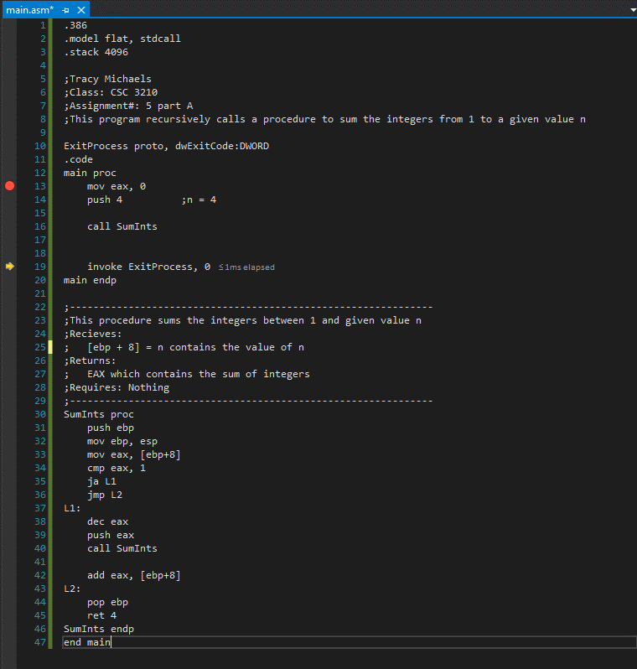

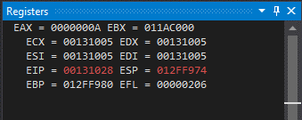

Part B

For recursive example from book:

48 Bytes when n = 3

(n+1) \* ( eax(4 Bytes) + return address(4bytes) + ebp(4 Bytes))

\*\*\*(n+1) since exit condition is 0

For answer from Part A:

36 Bytes when n = 3

(n) \* ( eax(4 Bytes) + return address(4bytes) + ebp(4 Bytes))

\*\*\*(n) since exit condition is 1